Chapter XII

Dynamic Arrays with the ArrayList Class

Chapter XII Topics

12.1 Introduction
12.2 ArrayList Methods
12.3 ArrayList & Primitive Data Types
12.4 ArrayList & Generics
12.5 ArrayList & the Enhanced For.. Each Loop
12.6 The Deck Class with ArrayList
12.7 Review of the Magpie Program
12.8 Summary

12.1 Introduction

Most programming languages have one type of array. Frequently the array data structure is - like the static array of the previous chapter - both one-dimensional and multi-dimensional. Java has two types of arrays. Java has the static array, shown in the last chapter, which is constructed with a fixed size that cannot be altered during program execution. Additionally, Java has a dynamic array, which does not require a predetermined size at instantiation and can be altered during program execution. The focus of this chapter is on the dynamic array, which is implemented with the ArrayList class.

You will see that the dynamic array is very different from the static array. The dynamic array is a modern array. The ArrayList class is a class with a constructor and lots of methods. Such is not the case with the static array. You do see the new operator as a reminder that some object is allocating space in memory, but there are no methods and access is only provided with some bracket index [ ] [ ] operators. In truth the static array dates back to the early days of programming and in many languages the array data structure works pretty much in the manner that you saw in the last chapter.

This chapter teaches you the modern array with many methods and there should be a question coming up. If we have a modern array, why bother with an old one. Pick the better one of the two arrays and reject the other one. This is a reasonable argument, but the truth is that both arrays have something to offer. By the time you have seen program examples with both types of arrays you should know the advantages of using each type.

Java Arrays
• Java has a static array capable of easy multi-dimensions.

• Java has a dynamic array, which is also capable of multi- dimensions, but it is more complex.

• The ArrayList class is used for the dynamic array.

• Static arrays have no methods, but have the initializer list.

• ArrayList is a class with many methods.

12.2 ArrayList Methods

Java has an answer to the static array shortcomings, which does not allow any change in size during program execution. It is the ArrayList class. With an ArrayList object the quantity of elements can be altered on the fly during program execution, which is officially known as dynamic resizing. Dynamic resizing it great, but there are other features available. Static arrays have a conspicuous absence of methods to enhance the data processing needs. The ArrayList class not only handles resizing, but it also has a convenient set of methods to manipulate data. Program Java1201.java, in figure 12.1, demonstrates how to construct an ArrayList object and it shows how to use the add method to add new elements to the array. New elements are added to the end of the ArrayList object.

Figure 12.1
// Java1201.java
// This program demonstrates the <add> method of the <ArrayList> class.
// Note that each name is added to the end of the list.

import java.util.ArrayList;

public class Java1201
{
public static void main(String[ ] args)
{
ArrayList names = new ArrayList();
names.add("Isolde");
names.add("John");
names.add("Greg");
names.add("Maria");
names.add("Heidi");

System.out.println("names contains " + names);
}
}

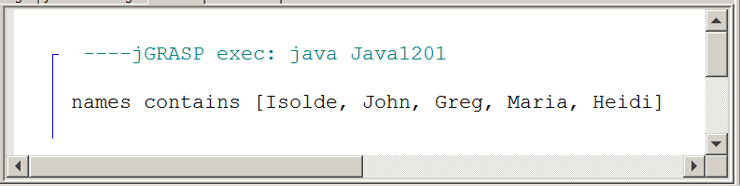
ArrayList Method add
names.add("Tom");

The add method allocates space for the newly enlarged array and then stores the new array element at the end of the ArrayList object.

You should have observed a feature of the ArrayList class that does not exist with Java static arrays. All the elements in the array are displayed rather casually with the use of a simple statement like System.out.println(names). This is a serious no-no with a static array. Actually, it is not a no-no in the compile sense. The result is not real practical. All you get is some memory address of the array storage location.

Displaying ArrayList Elements
ArrayList elements can be accessed with various methods. It is possible to display all the elements inside square brackets, separated by commas by using the println method.

The toString method has been re-defined in one of the super classes of the ArrayList class.

System.out.println(names);

[Isolde, John, Greg, Maria, Heidi]

Java static arrays use the length field to store the number of elements in an array object. A static array can access a field, because it is declared final and access is possible without the possibility of altering the field value. A dynamic array, like ArrayList uses a method, which alters a private field value. Program Java1202.java, in figure 12.2, demonstrates the use of the size method.

Figure 12.2
// Java1202.java
// This program uses the <size> method to determine the number of elements
// in an <ArrayList> object.
// Note that the value returned by the <size> method changes when more names
// are added to the <ArrayList> object.

import java.util.ArrayList;

public class Java1202
{
public static void main(String[ ] args)
{
ArrayList names = new ArrayList();
names.add("Isolde");
names.add("John");
names.add("Greg");
System.out.println("names contains " + names);;
System.out.println("There are " + names.size() + " elements in the names object.");

names.add("Maria");
names.add("Heidi");
System.out.println("names contains " + names);
System.out.println("There are " + names.size() + " elements in the names object.");
}
}

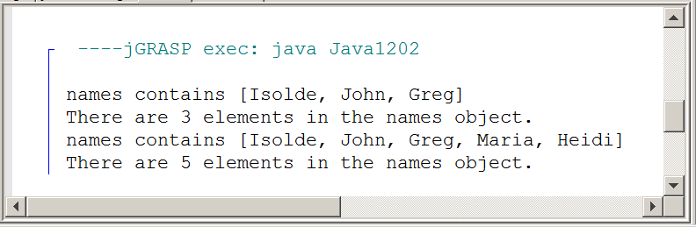

ArrayList Method size
int count = names.size();

The size method returns the number of elements of the ArrayList object names.

Program Java1203.java, in figure 12.3, shows how individual elements of the names object are accessed with the get method. Note how the size method controls the loop. Any attempt to access an array element at a location that does not exist, results in an IndexOutOfBoundsException error message, which is precisely what happens with static arrays.

Figure 12.3
// Java1203.java
// This program shows how to access specified elements in an <ArrayList> object
// with the <get(k)> method. This compares to using [k] in static arrays.
import java.util.ArrayList;

public class Java1203
{
public static void main(String[ ] args)
{
ArrayList names = new ArrayList();
names.add("Isolde");
names.add("John");
names.add("Greg");
names.add("Maria");
names.add("Heidi");
System.out.println();
for (int k = 0; k < names.size(); k++)
System.out.println(names.get(k));
System.out.println();

for (int k = names.size()-1; k >= 0; k--)
System.out.println(names.get(k));
}
}

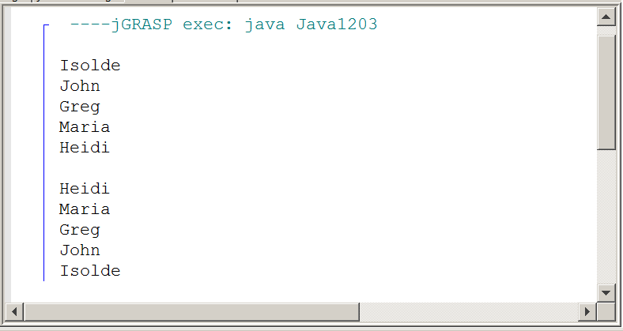
ArrayList Method get
System.out.println(names.get(3));

The get method accesses a specified array element. The parameter of the get method is the index of the ArrayList object and starts at 0.

The static array index operator is very versatile. It can be used to access array elements for display and it can also be used to change the value of an array element. ArrayList methods are more specialized. The get method is fine for displaying individual elements, but another method is required to alter any values. This job is performed by the set method. Method set requires two parameters, one for the array element index and a second parameter for the new array element value. Program Java1204.java, in figure 12.4, starts with five initial names and then changes four of the names.

Figure 12.4
// This program demonstrates the <set> method of the <ArrayList> class, which
// replaces existing elements with a new object. Note that the <set> method is a return
// method that returns the last element value before it is replaced.

import java.util.ArrayList;

public class Java1204
{
public static void main(String[ ] args)
{
ArrayList names = new ArrayList();
names.add("Isolde");
names.add("John");
names.add("Greg");
names.add("Maria");
names.add("Heidi");
System.out.println("names contains " + names);
System.out.println();

names.set(1,"Jessica");
names.set(2,"Anthony");
names.set(3,"Haley");
System.out.println(names.set(4,"Alec"));

System.out.println("names contains " + names);
}
}

Figure 12.4 Continued
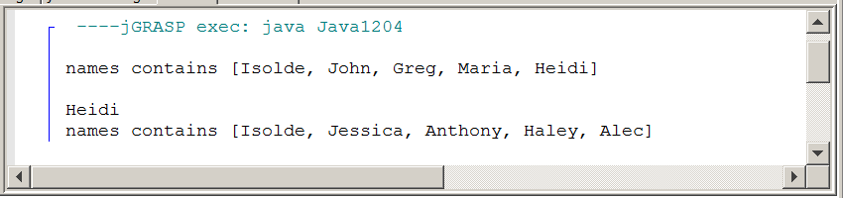

ArrayList Method set
names.set(4,"Tom");

The set method uses the first parameter as the index location to find an array element and then replaces it with the value of the second set parameter. You will get an error if you try to access an index location, which has not been allocated yet.
The set method also returns the last value before replacing it.

Earlier in this chapter, ArrayList was advertised as a dynamic array. Dynamic in the sense that resizing is possible during program execution. You have seen objects grow in size by adding additional elements. Resizing also can be used to make an array data structure smaller. Program Java1205.java, in figure 12.5, resizes the array with the remove method. Method remove requires a single parameter, which is the index of the array element to be removed.

Figure 12.5
// Java1205.java
// This program demonstrates the <remove> method of the <ArrayList> class to
// delete a specified list element.

import java.util.ArrayList;

public class Java1205
{
public static void main(String[ ] args)
{
ArrayList names = new ArrayList();
names.add("Isolde");
names.add("John");
names.add("Greg");
names.add("Maria");
names.add("Heidi");
System.out.println("names contains " + names);
System.out.println();
names.remove(2);
System.out.println("names contains " + names);
System.out.println();
names.remove(3);
System.out.println("names contains " + names);
System.out.println();
}
}

Figure 12.5 Continued
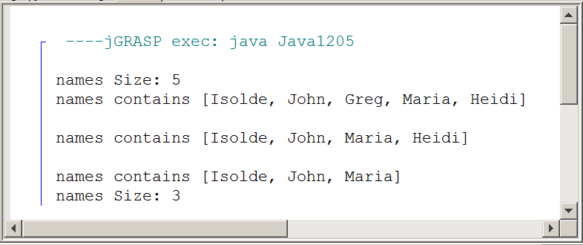

ArrayList Method remove
names.remove(3);

The remove method removes the array element at the index location of its parameter and decreases the object size by one array element.

The add method is overloaded. An earlier program example introduced the add method with a single parameter. This single parameter provides the value of a new array element, which is added as the last element of the array. It is also possible to add a new element at a specified location. Be careful and do not confuse this second add method with the set method. Method set alters the value at a specified index. The overloaded add method inserts a new array element at a specified index and in the process bumps elements to the next index value. Program Java1206.java, in figure 12.6, will appear similar to the previous set program example.
Figure 12.6
// Java1206.java
// This program demonstrates how to use the <add> method of the <ArrayList> class to
// insert new elements at a specified location.

import java.util.ArrayList;

public class Java1206
{
public static void main(String[ ] args)
{
ArrayList names = new ArrayList();
names.add("Isolde");
names.add("John");
names.add("Greg");
names.add("Maria");
names.add("Heidi");
System.out.println("names contains " + names);
System.out.println();
names.add(2,"Jessica");
System.out.println("names contains " + names);
System.out.println();
names.add(3,"Anthony");
System.out.println("names contains " + names);
}
}

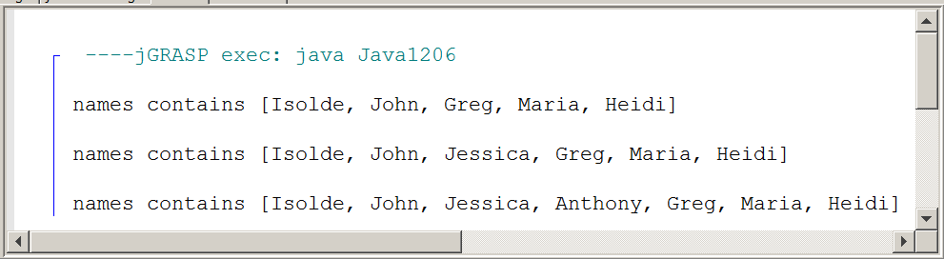

ArrayList Method add (second overloaded add)
names.add(3,"Kathy");

The overloaded add(3,"Kathy") method adds or rather inserts a new array element at the indicated index.

There are more methods in the ArrayList class. The six methods in this section are AP tested methods, because they are the most common methods and allow a wide range of data processing with a dynamic array.

It may seem that the ArrayList, with all its methods and dynamic resizing, is so superior to the static array that there exists little justification to hang on to a type of array that goes back to the early days of programming.

The simple reality is that ArrayList, good and flexible as it may be, is primarily a one-dimensional array. There exists plenty of processing that calls for two or more dimensional processing in the real computing word. Multi-dimensional arrays are easier to access with the static array. Furthermore, the convenience of constructing a new array with a set of initial values, using the initializer list, is very easy with static arrays and does not exist with the ArrayList class.

AP Computer Science Exam Alert
The ArrayList class is tested on the AP exam with the following six methods:

int size()

boolean add(E obj)

void add(int index, E obj)

E get(int index)

E set(int index, E obj)

E remove(int index)

In the method headings above E is the data type of the Element that is added or returned.

12.3 ArrayList and Primitive Data Types

In Chapter VI the Integer class was introduced. The Integer class is a wrapper class, which stores int values in an object. This is very important for data structures that can only store object values. The static array is quite relaxed about such issues and can store both primitive types and objects. Many classes, like the ArrayList, only store objects.

This does not mean that primitive types are off limits to an ArrayList object. Courtesy of the Integer class program Java1207.java, in figure 12.7, does a fine job storing int values. Try running the program with "commented-out" line, which proves that Integer objects are not int values and cannot be treated as such, like trying arithmetic addition.

Figure 12.7
// Java1207.java
// This program demonstrates how <int> values stored into an <ArrayList>
// object are first converted to <Integer> objects.
// The <Integer> class is called a "wrapper" class.
import java.util.ArrayList;
public class Java1207
{
public static void main(String[ ] args)
{
ArrayList numbers = new ArrayList();
for (int k = 1; k <= 200; k++)
{
int rndInt = (int) (Math.random() * 900 + 100);
numbers.add(new Integer(rndInt));
System.out.print(rndInt + " ");
if (k % 15 == 0)
System.out.println();
}
int sum = 0;
for (int k = 0; k < numbers.size(); k++)
{
Integer temp = (Integer) numbers.get(k);
sum += temp.intValue();
// sum += numbers.get(k);
}
System.out.println("\n\nSum: " + sum);
}
}
Figure 12.7 Continued
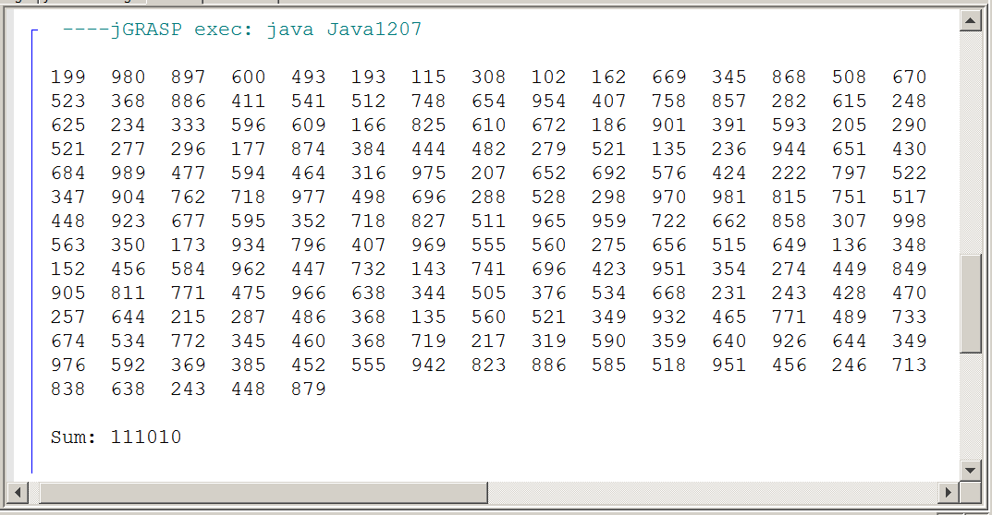

The same approach can be used for other primitive data types, such as double and boolean. These primitive types both have wrapper classes Double and Boolean, which can be used to store simple data types as objects in the ArrayList class.

ArrayList and Primitive Data Types
The ArrayList class can only store Object values.

Primitive data type values can be stored indirectly using wrapper classes.

The Integer class wraps int values.
The Double class wraps double values.
The Boolean class wraps boolean values.

12.4 ArrayList and Generics

Java version 5.0 solved some problems with Java classes. Prior to Java 5.0 there was a problem with handling objects. An object stores a reference, which is a memory address. Now at this memory address actual practical data information can be stored of any type. However, this information can be any type and that can cause confusion and peculiarities.

Consider program Java1208.java, in figure 12.08. This program shows an ArrayList object which properly stores Person objects as its elements. Two Person objects are instantiated and then added to the people object. When an attempt is made to access individual people objects the program complains and causes syntax errors. The error message indicates incompatible types. This may seem to be a mystery, because only Person objects are used and how can they be incompatible? The problem is that the actual value stored for each people object is a reference and its data type is unknown.

Figure 12.8
// Java1208.java
// This program has no output, which does not matter, because it does not compile.
// You will see two "incompatible types" syntax errors. This may seem strange
// because the <ArrayList> object stores <Person> objects.

import java.util.ArrayList;

public class Java1208
{
public static void main(String[ ] args)
{
ArrayList people = new ArrayList();
people.add(new Person("Joe",21));
people.add(new Person("Sue",20));
Person student1 = people.get(0);
Person student2 = people.get(1);
}
}

class Person
{
private String name;
private int age;

public Person (String n, int a)
{
name = n;
age = a;
}
}

Figure 12.8 Continued
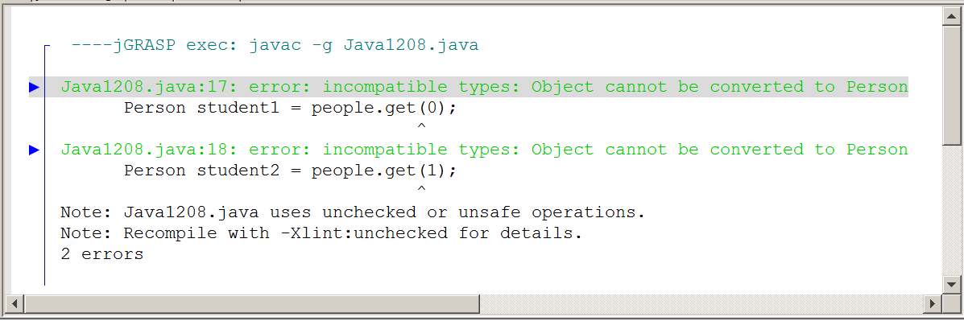

Prior to Java 5.0 there was, and still is, a solution to the unknown data type problem. Program Java1209.java, in figure 12.9, is almost identical to the previous program, but two very strategic castings are used. In each assignment statement, Person student1 = (Person) people.get(0); the casting of the object to (Person) provides Java with the required information.

Figure 12.9
// Java1209.java
// This program compiles and there is still no output. Output is not the
// issue. Understanding the correct syntax involved does matter.
// In this case lines 18 and 19 cast to the <Person> class, which makes Java happy.

import java.util.ArrayList;

public class Java1209
{
public static void main(String[ ] args)
{
ArrayList people = new ArrayList();
people.add(new Person("Joe",21));
people.add(new Person("Sue",20));
Person student1 = (Person) people.get(0);
Person student2 = (Person) people.get(1);
}
}

class Person
{
private String name;
private int age;

public Person (String n, int a)
{
name = n;
age = a;
}
}
Figure 12.9 Continued
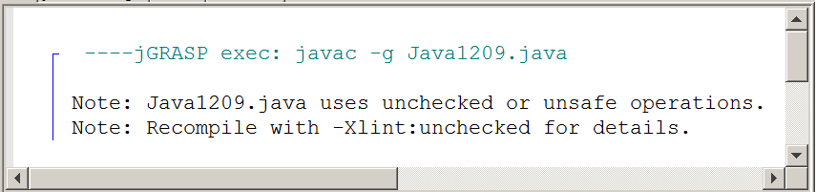

The program may compile, but continues to warn and complain about unchecked and unsafe operations. What is that all about? Well along comes Java 5.0 and now Java has a better solution, which is known as generics. The selection of this term will make more sense in a later chapter. At the instantiation of a new ArrayList object the data type to be stored is specified. Look at Java1210.java, in figure 12.10, and you will see the following statement:

ArrayList<Person> people = new ArrayList<Person>();

This statement tells Java that the new people object will only store objects of the Person class. Casting is no longer necessary. This approach also creates an excellent where the code makes it clear what is stored in the new array.

Figure 12.10
// Java1210.java
// Since Java Version 5.0 the "casting" solution of the last program is so old Java version".
// You can now specify - at the time that the <ArrayList> object is constructed - what is stored.
// This is called "generics" and in this case Java knows it is <Person>.

import java.util.ArrayList;

public class Java1210
{
public static void main(String[ ] args)
{
ArrayList<Person> people = new ArrayList<Person>();
people.add(new Person("Joe",21));
people.add(new Person("Sue",20));
Person student1 = people.get(0);
Person student2 = people.get(1);
}
}

class Person
{
private String name;
private int age;

public Person (String n, int a)
{
name = n;
age = a;
}
}
Figure 12.10 Continued
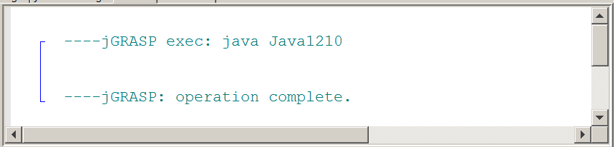

Java1210 compiles and executes without any errors and even the annoying unchecked and unsafe operations warning has disappeared. Java is sure happy.

Program Java1212.java, in figure 12.11, shows how nicely a Java program works with the generic feature. You now see a program, which starts with a number1 object. This object is instantiated to store Integer objects and three numbers are stored in numbers1.

A second ArrayList object, numbers2, is instantiated with the same intention to store int values wrapped inside Integer objects. This is followed by accessing three elements from numbers1 and assigning all three to numbers2. This works flawlessly without a hitch.

Figure 12.11
// Java1211.java
// This program shows another benefit of using generics.
// There are two <ArrayList> objects and both are constructed
// to store <Integer> values. After three values are entered
// in the <numbers1> object, those values are then assigned
// to <numbers2>, which works without problems.

import java.util.ArrayList;

public class Java1211
{
public static void main(String[ ] args)
{
ArrayList<Integer> numbers1 = new ArrayList<Integer>();
numbers1.add(new Integer(100));
numbers1.add(new Integer(200));
numbers1.add(new Integer(300));
System.out.println(numbers1);

ArrayList<Integer> numbers2 = new ArrayList<Integer>();
numbers2.add(numbers1.get(0));
numbers2.add(numbers1.get(1));
numbers2.add(numbers1.get(2));
System.out.println(numbers2);
}
}

Figure 12.11 Continued
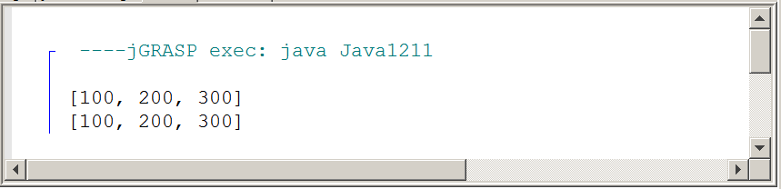

It was mentioned earlier that an array by definition is a data structure with elements of the same type. Consider what happens when generics are not used. Program Java1212.java, in figure 12.12, adds a Double object and an Integer object and then finally a String object in the array. Java - without generics - allows this practice and the resulting structure is hardly a proper array.

Figure 12.12
// Java1212.java
// Generics make sure that an array is in fact an array. An array
// is supposed to be a data structure with elements of the same type.
// This program example - which does not use generics - allows the
// list array to store three different data types.

import java.util.ArrayList;

public class Java1212
{
public static void main(String[ ] args)
{
ArrayList list = new ArrayList();
list.add(new Double(3.14159));
list.add(new Integer(200));
list.add(new String("Dubrovnik"));
System.out.println(list);
}
}

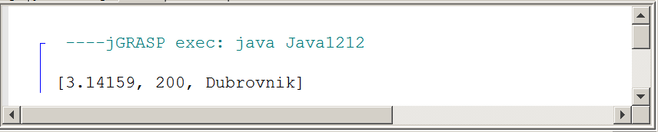

Program Java1213.java, in figure 12.13, uses the proper approach to instantiate an ArrayList object. Like before, an attempt is made to enter three different values into the array. Java rewards the programmer with two error messages.
Figure 12.13
// Java1213.java
// Once generics are used, Java becomes very picky. If you want to create an
// <ArrayList> object to store <Double> values, such as is shown below, then only
// <Double> values must be added. The attempt to add one <Double>, one <Integer>
// and one <String> object results in two errors, and a lot of explanations.

import java.util.ArrayList;

public class Java1213
{
public static void main(String[ ] args)
{
ArrayList<Double> list = new ArrayList<Double>();
list.add(new Double(3.14159));
list.add(new Integer(200));
list.add(new String("Dubrovnik"));
System.out.println(list);
}
}

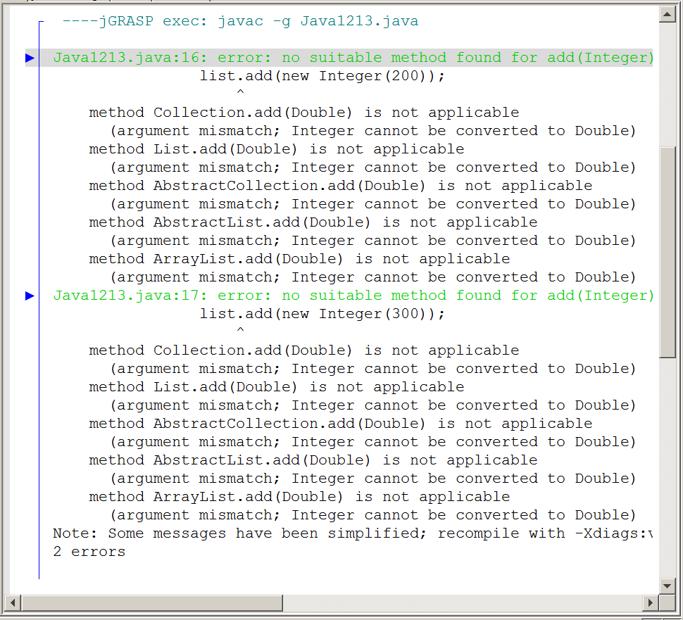
12.5 ArrayList & the Enhanced For Loop

Since we are on the subject of Java 5.0 enhancements with generics, let us continue and check out the special for..each loop structure. This loop structure was first shown with the static arrays in the last chapter. It was necessary to wait for the array structure because the for..each loop cannot work with primitive data types. You need a data structure, like an ArrayList object.

Program Java1214.java, in figure 12.14, presents three displays. The first output is done directly with println and the names object. You have seen this before.

The second output uses the original for loop and visits every element of the names array. The loop counter variable is used to access each array element starting with index 0 and continue until the names.size() - 1 index.

Finally, the for..each loop is used. Note the convention of selection variable name of type String to represent the single element. This convention provides readability. We can now read the loop statement as: for each String element, called name in the object names, display the value of name.

Figure 12.14
// Java1214.java
// The final program in this chapter shows three ways to display the members of an
// <ArrayList> object. Note that the <for..each> loop works very well with <ArrayList>.

import java.util.ArrayList;

public class Java1214
{
public static void main(String[ ] args)
{
ArrayList<String> names = new ArrayList<String>();
names.add("Isolde");
names.add("John");
names.add("Greg");
names.add("Maria");
names.add("Heidi");
System.out.println(names);
System.out.println();
for (int index = 0; index < names.size(); index++)
System.out.println(names.get(index));
System.out.println();
for (String name: names)
System.out.println(name);
}
}

Figure 12.14 Continued
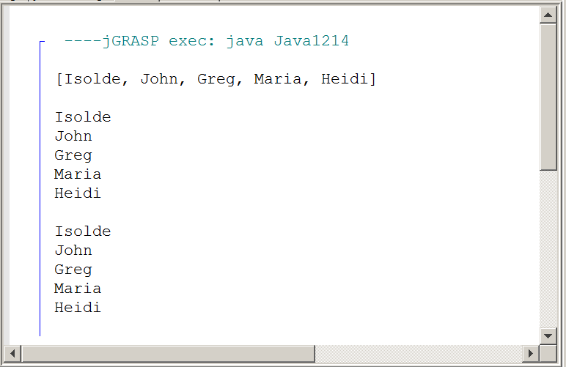

12.6 The Deck class With ArrayList

This chapter section will be very familiar. It is a repeat of the same set of programs that were presented in the previous chapter. The key difference is that now the array data structure of the Deck class will be implemented with the dynamic ArrayList class.

Making this switch is not simply a matter of replacing the static array cards declaration with an ArrayList version. There is a major difference in array access of individual elements. Static arrays access array elements with the [ ] index operators. Dynamic arrays use methods.

Just to make sure let us first start and take another quick look at the Card class code. Every member of the array is an object of the Card class. These objects are not altered by static or dynamic array structures. The same exact Card class declaration will be used for both array implementations.
Figure 12.15 shows the Card class version that is used for the Deck class in both the static array and the dynamic array chapters. This version is not completely identical to the one used for the Elevens Lab. The actual Elevens lab program includes some features that have not been taught yet.

This class presents nothing new. It is here to give you a good look before we investigate the new Deck class. The programs presented in this section will use the "one class, one file" approach. This is proper program design. For one program there will be three files involved. You will look at a Deck01 class in the Deck01.java file, using the Card class, in the Card.java file and is tested by the DeckTester01 class, in the DeckTester01.java file.

Figure 12.15
// Card.java 12-26-14
// This is the "unit" class that stores information about a single card.
// *******************************************************************************
// The "Elevens" AP Lab is created for the College Board APCS
// curriculum by Michael Clancy, Robert Glen Martin and Judith Hromcik.
// Leon Schram has altered this "Elevens" AP Lab file to focus on
// CS topics as the "Elevens" Lab is integrated into the curriculum.
public class Card
{
private String suit;
private String rank;
private int value;
public Card(String s, String r, int v)
{
suit = s;
rank = r;
value = v;
}
public String getSuit() { return suit; }
public String getRank() { return rank; }
public int getValue() { return value; }
public boolean matches(Card otherCard)
{
return otherCard.getSuit().equals(this.suit)
&& otherCard.getRank().equals(this.rank)
&& otherCard.getValue() == this.value;
}
public String toString()
{
return "[" + suit + ", " + rank + ", " + value + "]";
}
}
The Deck01 class, in figure 12.16, has similarities and differences with its cousins shown in the static array chapter. The ArrayList class is right away visible and you will see that the Card class will be used for individual elements of the cards array. The static array starts with size 52 and the dynamic array starts empty. In a dynamic array space is not allocated until it is needed and some value can be stored in the space.

You may be tempted to run this file, but it is a class without a main method or applet and can be compiled to create a class file, but cannot be executed.

Figure 12.16
// Deck01.java 12-26-14
// This is the first stage of the Deck class, as introduced
// in the previous "Static Arrays" chapter.
// This version is implemented with "dynamic arrays".
// *******************************************************************************
// The "Elevens" AP Lab is created for the College Board APCS
// curriculum by Michael Clancy, Robert Glen Martin and Judith Hromcik.
// Leon Schram has altered this "Elevens" AP Lab file to focus on
// CS topics as the "Elevens" Lab is integrated into the curriculum.
import java.util.ArrayList;
public class Deck01
{
private ArrayList<Card> cards;
private int size;
public Deck01()
{
cards = new ArrayList<Card>();;
size = 0;
}
public int getSize()
{
return size;
}
public boolean isEmpty()
{
return size == 0;
}
}

The DeckTester01 class, in figure 12.17, tests the Deck01 class. You see a memory reference for the deck object. You should then instantly recognize that the toString method is not re-defined for the Deck01 class. Don't get confused here. You have seen that ArrayList objects can display individual members just fine, but we used deck in the print statement and not cards.

Methods getSize and isEmpty properly do their job and report that the array is right now size 0 and it is true that the array is empty. It is a simple test, but it allows us to move on and become more complex.

The Card class is actually not tested at this stage. Nowhere is an object of the Card class constructed. Also note that there is a Card class, not Card01, Card02 andCard03. The Card class will not be altered. It is fine as it is and the same class works for static and dynamic arrays.

Figure 12.17
// DeckTester01.java 12-26-14
// This program tests the "dynamic array" Deck01 class.
// *******************************************************************************
// The "Elevens" AP Lab is created for the College Board APCS
// curriculum by Michael Clancy, Robert Glen Martin and Judith Hromcik.
// Leon Schram has altered this "Elevens" AP Lab file to focus on
// CS topics as the "Elevens" Lab is integrated into the curriculum.
public class DeckTester01
{
public static void main(String[ ] args)
{
Deck01 deck = new Deck01();
System.out.println(deck);
System.out.println(deck.getSize());
System.out.println(deck.isEmpty());
}
}

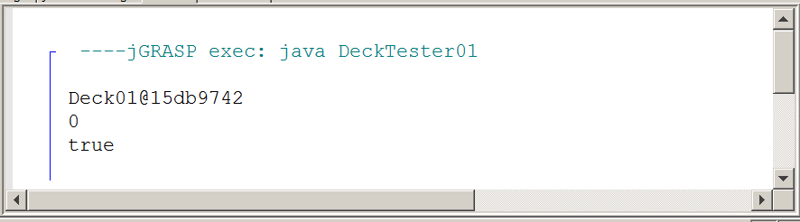
The Deck02 class, in figure 12.18, makes the class practical. It is now possible the add cards to the deck and it is also possible to display the individual cards that have been added.

Figure 12.18
// Deck02.java 12-26-14
// Methods <add> and <display> are added to the <Deck02> class.
// Objects of the <Card> class can now be stored in the <cards> array.
// This version is implemented with "dynamic arrays"
// ********************************************************************************
// The "Elevens" AP Lab is created for the College Board APCS
// curriculum by Michael Clancy, Robert Glen Martin and Judith Hromcik.
// Leon Schram has altered this "Elevens" AP Lab file to focus on
// CS topics as the "Elevens" Lab is integrated into the curriculum.
import java.util.ArrayList;
public class Deck02
{
private ArrayList<Card> cards;
private int size;
public Deck02()
{
cards = new ArrayList<Card>();
size = 0;
}
public int getSize()
{
return size;
}
public boolean isEmpty()
{
return size == 0;
}
public void add(String suit, String rank, int value)
{
Card temp = new Card(suit,rank,value);
cards.add(temp);
size++;
}
public void display()
{
for (Card card: cards)
System.out.println(card);
}
}

The DeckTester02 class, in figure 12.19, has to ability to do some better testing. After a Deck02 object is constructed, four new cards are added to the deck. The add method and display method is then tested along with getSize and isEmpty.

When you look at the display method in the Deck02 class, there is no evidence of any type of output format. The cards are displayed like [Clubs, Three, 3] and this is the result of the toString method found in the Card class.

Figure 12.19
// DeckTester02.java 12-26-14
// This program tests the <Deck02> class.
// This program tests the "dynamic array" Deck02 class.
// *******************************************************************************
// The "Elevens" AP Lab is created for the College Board APCS
// curriculum by Michael Clancy, Robert Glen Martin and Judith Hromcik.
// Leon Schram has altered this "Elevens" AP Lab file to focus on
// CS topics as the "Elevens" Lab is integrated into the curriculum.
public class DeckTester02
{
public static void main(String[ ] args)
{
Deck02 deck = new Deck02();
deck.add("Clubs","Three",3);
deck.add("Diamonds","Four",4);
deck.add("Hearts","Five",5);
deck.add("Spades","Six",6);
deck.display();
System.out.println(deck.getSize());
System.out.println(deck.isEmpty());
}
}

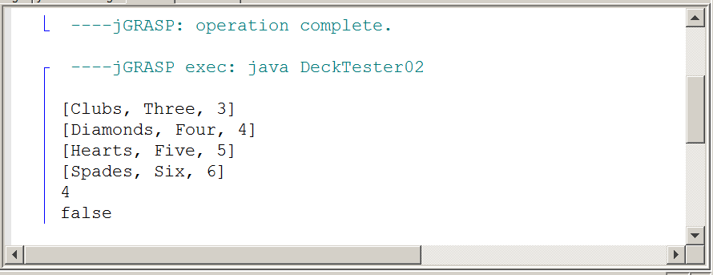
The Deck03 class, in figure 12.20, replaces the display method with the toString method. Note that the code in the toString method shows an example of toString inside toString. The Deck03 class has a cards array data structure and each element of the cards object is a Card object.

Figure 12.20
// Deck03.java 12-26-14
// The <display> method is now replaced by the <toString> method.
// This version is implemented with "dynamic arrays".
// *******************************************************************************
// The "Elevens" AP Lab is created for the College Board APCS
// curriculum by Michael Clancy, Robert Glen Martin and Judith Hromcik.
// Leon Schram has altered this "Elevens" AP Lab file to focus on
// CS topics as the "Elevens" Lab is integrated into the curriculum.
import java.util.ArrayList;
public class Deck03
{
private ArrayList<Card> cards;
private int size;
public Deck03()
{
cards = new ArrayList<Card>();
size = 0;
}
public int getSize() { return size; }
public boolean isEmpty() { return size == 0; }
public void add(String suit, String rank, int value)
{
Card temp = new Card(suit,rank,value);
cards.add(temp);
size++;
}
public String toString()
{
String temp = "";
for (Card card: cards)
temp = temp + card.toString() + "\n";
return temp;
}
}

This sequence of the Deck class now concludes with testing the latest version in figure 12.21. The main method is changed little from the last test. The display method is now replaced by printing the deck object. The result is an absolutely identical output of the last test.

Figure 12.21
// DeckTester03.java 12-26-14
// This program tests the Deck03 class.
// This program tests the "dynamic array" Deck03 class.
// *******************************************************************************
// The "Elevens" AP Lab is created for the College Board APCS
// curriculum by Michael Clancy, Robert Glen Martin and Judith Hromcik.
// Leon Schram has altered this "Elevens" AP Lab file to focus on
// CS topics as the "Elevens" Lab is integrated into the curriculum.
public class DeckTester03
{
public static void main(String[ ] args)
{
Deck03 deck = new Deck03();
deck.add("Clubs","Three",3);
deck.add("Diamonds","Four",4);
deck.add("Hearts","Five",5);
deck.add("Spades","Six",6);
System.out.println(deck);
System.out.println(deck.getSize());
System.out.println(deck.isEmpty());
}
}

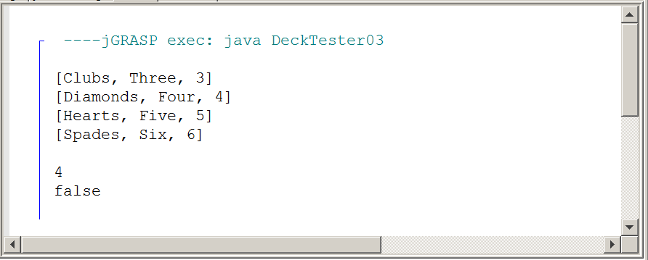
12.7 Review of the Magpie Program

This one-dimensional dynamic array chapter will conclude with another look at the Magpie, Chatbot program. This may seem odd in an array chapter, but the inclusion of this topic will make sense shortly.

First, we need to do a quick review and look at the last version of the Magpie program sequence, which is shown in figure 12.22.

Figure 12.22
// Magpie01.java 12-26-14
// This "Magpie" version looks only at the "negative" response
// and considers all the different cases of a "no" substring.
//***********************************************************************
// The "Magpie" AP Lab is created for the College Board APCS
// curriculum by Laurie White.
// Leon Schram has altered this "Magpie" file to focus on
// CS topics as the "Magpie" Lab is integrated into the curriculum.
public class Magpie01
{
public String getGreeting()
{
return "Hello, let's talk.";
}
public String getResponse(String statement)
{
String response = "";
if (statement.length() == 0)
{
response = "Say something, please.";
}
else if (findKeyword(statement, "no") >= 0)
{
response = "Why so negative?";
}
else
{
response = "I don't know what to say";
}
return response;
}

private int findKeyword(String statement, String goal,int startPos)
{
String phrase = statement.trim();
int psn = phrase.toLowerCase().indexOf(goal.toLowerCase(), startPos);
while (psn >= 0)
{
String before = " ", after = " ";
if (psn > 0)
{
before = phrase.substring(psn - 1, psn).toLowerCase();
}
if (psn + goal.length() < phrase.length())
{
after = phrase.substring(psn + goal.length(),psn + goal.length() + 1).toLowerCase();
}
if (((before.compareTo("a") < 0) || (before.compareTo("z") > 0))
&& ((after.compareTo("a") < 0) || (after.compareTo("z") > 0)))
{
return psn;
}
psn = phrase.indexOf(goal.toLowerCase(),psn + 1);
}
return -1;
}
private int findKeyword(String statement, String goal)
{
return findKeyword(statement, goal, 0);
}
}

This version of the Magpie case study was quite complicated. The program started out comfortably asking for input and answered as follows:

If you used no the chatbot responded with: Why so negative?

If you answered anything besides no the chatbot responded with:
I don't know what to say

The variety of responses was very limited when we last looked at Magpie, but the no problem was handled nicely. Earlier versions would consider words, like nothing, know, notice, noel to be reasons for the why so negative response.

In an effort to focus on the NO problem, other logical responses related to family and various random responses had been removed. Program MagpieTester01 in figure 12.23 tests the Magpie01 class and figure 12.24 shows a sample of responses from that execution.

Figure 12.23
// MagpieTester01.java 12-26-14
// This program tests the Magpie01 class.
// ************************************************************************
// The "Magpie" AP Lab is created for the College Board APCS
// curriculum by Laurie White.
// Leon Schram has altered this "Magpie" file to focus on
// CS topics as the "Magpie" Lab is integrated into the curriculum.
import java.util.Scanner;
public class MagpieTester01
{
public static void main(String[ ] args)
{
Magpie01 maggie = new Magpie01();
System.out.println (maggie.getGreeting());
Scanner in = new Scanner (System.in);
String statement = in.nextLine();
while (!statement.equals("Bye"))
{
System.out.println (maggie.getResponse(statement));
statement = in.nextLine();
}
}
}

Figure 12.24
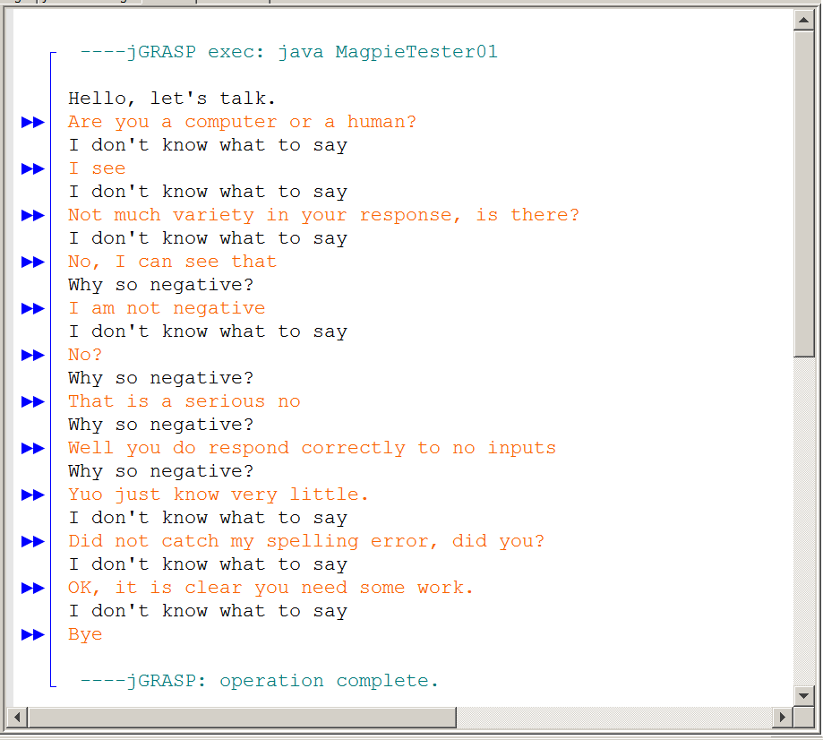
Figure 12.24 Continued

There is no question that the whole NO business is handled properly. You can try all sorts of possibilities. Have "no" at the start or at the end or by itself or in the middle. Have no without other characters and no with quotes or parenthesis. Try it all sorts of ways and you will find that this Magpie01 has all the different cases covered. It is not easy to achieve that.

However, this is an array chapter and we need to put arrays to work with the chatbot program. With an emphasis on focus, we are now returning to an earlier Magpie program. This version, listed here as Magpie02, and shown in figure 12.25, is an early version when "no" was a problem. But it does also handle input for family names and it does show the four random responses when family input and no are not applicable.

In program design it is normal to totally focus on a single class and make sure that the class works correctly. This process can be applied as well within the class. The Magpie class is quite large and in the process of improving the capabilities of the chatbot responses we focus on different parts of the class.

This is an array chapter and arrays are ideal for multiple responses. Right now there are 4 random responses. Implementing these 4 responses had been done with nested if else statements. This works fine, and it is not any problem with a limited set of responses. What if there are 100 responses, or more? The array data structure will be used to handle this issue in one of your lab assignments.

Figure 12.25
// Magpie02.java 12-26-14
// This Magpie version provides the following responses:
// 1. "Why so negative" when substring "no" is found.
// (This is the simplistic version for any "no" anywhere)
// 2. "Tell me more about your family" when relatives are found.
// 3. Otherwise one of four random responses is provided.
//*************************************************************************
// The "Magpie" AP Lab is created for the College Board APCS
// curriculum by Laurie White.
// Leon Schram has altered this "Magpie" file to focus on
// CS topics as the "Magpie" Lab is integrated into the curriculum.
public class Magpie02
{
public String getGreeting()
{
return "Hello, let's talk.";
}
public String getResponse(String statement)
{
String response = "";
if (statement.indexOf("no") >= 0)
{
response = "Why so negative?";
}
else if (statement.indexOf("mother") >= 0 || statement.indexOf("father") >= 0
|| statement.indexOf("sister") >= 0 || statement.indexOf("brother") >= 0)
{
response = "Tell me more about your family.";
}
else
{
response = getRandomResponse();
}
return response;
}
private String getRandomResponse()
{
final int NUMBER_OF_RESPONSES = 4;
double r = Math.random();
int whichResponse = (int)(r * NUMBER_OF_RESPONSES);
String response = "";
if (whichResponse == 0)
{
response = "Interesting, tell me more.";
}
else if (whichResponse == 1)
{
response = "Hmmm.";
}
else if (whichResponse == 2)
{
response = "Do you really think so?";
}
else if (whichResponse == 3)
{
response = "You don't say.";
}
return response;
}
}

The program to test Magpie02, in figure 12.26, brings no surprises. The testing programs are almost identical to the previous version. The bigger issue is to check the output of the testing process and understand how this Magpie version works. Figure 12.27 shows a rather lengthy testing run.

Figure 12.26
/*
* A simple class to run the Magpie class.
* This version tests the Magpie02 class.
**********************************************************
* author Laurie White
* version April 2012
* Divided into stages and altered December 2014 by Leon Schram
*/
import java.util.Scanner;
public class MagpieTester02
{
public static void main(String[ ] args)
{
Magpie02 maggie = new Magpie02();
System.out.println (maggie.getGreeting());
Scanner in = new Scanner (System.in);
String statement = in.nextLine();
while (!statement.equals("Bye"))
{
System.out.println (maggie.getResponse(statement));
statement = in.nextLine();
}
}
}

Figure 12.27
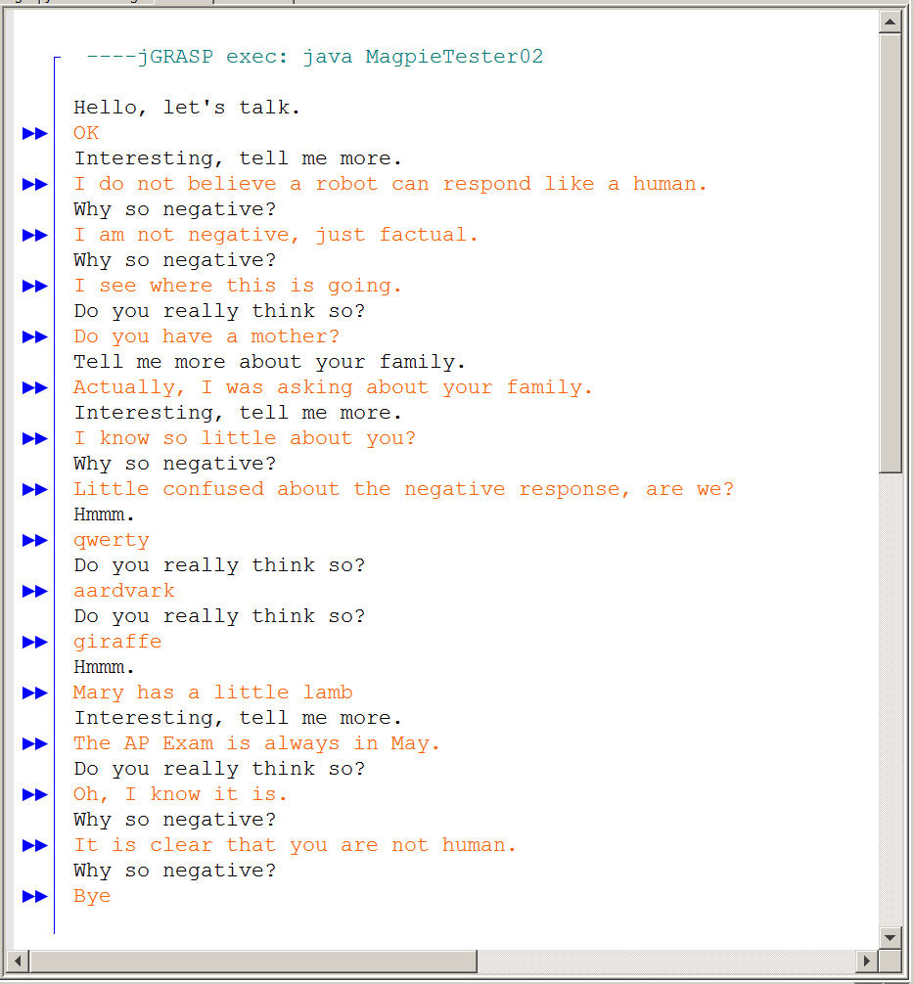

12.8 Summary

Java has two array data structures. There is the static array, shown in the last chapter, which cannot be resized during program execution. The static array also does not have any methods. However, on the plus side static arrays are very convenient for multi-dimensional arrays and they have initializer lists.

The second array, introduced in this chapter, is a dynamic array implemented with the ArrayList class. The dynamic array can be resized during program execution and there are many methods to process the data. The six most common methods are shown next and they are also tested on the AP Exam.

ArrayList Method add
names.add("Tom");

The add method allocates space for the newly enlarged array and then stores the new array element at the end of the ArrayList object.

ArrayList Method size
int count = names.size();

The size method returns the number of elements of the ArrayList object names.

ArrayList Method get
System.out.println(names.get(3));

The get method accesses a specified array element. The parameter of the get method is the index of the ArrayList object and starts at 0.

Any attempt to access an element at a non-existing index results in an IndexOutOfBoundsException error.

ArrayList Method set
names.set(4,"Tom");

The set method uses the first parameter as the index location to find an array element and then replaces it with the value of the second set parameter. You will get an error if you try to access an index location, which has not been allocated yet.

ArrayList Method remove
names.remove(3);

The remove method removes the array element at the index location of its parameter and decreases the object size by one array element.

You will get an error if you try to access an index location, which does not exist.

ArrayList Method add (second overloaded add)
names.add(3,"Kathy");

The overloaded add(3,"Kathy") method adds or rather inserts a new array element at the indicated index.

ArrayList objects cannot store primitive data values directly. Some wrapper class, like Integer, Double or Boolean must be used to store simple data values.

Prior to Java 5.0 a program could not tell the type of value stored in an object, like an ArrayList object. Frequently casting was necessary to assign values. With Java 5.0 generics are possible, which means that at instantiation the data type of the ArrayList element is specified in a declaration like:

ArrayList<Card> cards = new ArrayList<Card>();

The enhanced for..each loop, introduced with static arrays also works very well with dynamic arrays.

In modern Object Oriented Programming an data structure, like an array, is placed inside a class as an object attribute. The Deck class is a good example. We start with a unit class, like the Card class. Objects of the Card class are then used as members of a cards array. We have seen that this cards array can be either a static array or a dynamic array.

Once the array data structure is decided, method can be created to access and process the array inside a Deck class. You are observing two good examples of Object Oriented Programming. The cards array data structure, along with its accessing methods are all contained inside one class. This is encapsulation.

The Deck class uses an existing class, the ArrayList class and there is now a has-a relationship. The Deck class has-an object of the ArrayList class. This is another OOP feature, called composition.

The array data structure also assists in improving the Magpie-Chatbot lab by making random responses easier to manage by using an array to store many responses that can be used at random.

